**AWS Masters Programs**

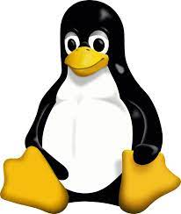**Linux Foundation:**

* **Basic commands**
* **Working With Files and Editors**
* **User Administration**
* **Linux Security System**
* **Archieving and Filtering**
* **Job Scheduling**
* **Package Management**
* **Partition**
* **Networking and Firewall**
* **Process Management**
* **Boot Procedure**
* **Web Servers- Apache,Nginx,Tomcat**
* **Mariadb**
* **FTP**
* **NFS**

** Cloud Computing:**

* **Introduction to AWS**
* **IAM**
* **Storage Service-**

->**S3**

**->EBS**

**->EFS**

* **Computing Service-**

**->EC**

* **Networking Service-**

**->VPC**

**Route-53**

**->CDN**

* **Monitoring Service-**

**->Cloud Watch**

* **Serverless Computing-**

**->Lambda**

* **Database Service-**

**->RDS**

**->DynamoDB**

* **Provisioning Service-**

**->Cloud Formation**

* **Notifications-**

**->SNS**

**->SQS**